Number of generations

Number of individuals

Number of tests in single series

Elite size

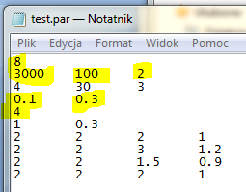

Number of initial mutations

Probability of mutation

Probability of crossover

The number of generations and the number of individuals are already adjusted. The following parameters must be checked:

|  |  |  |  |  |
| --- | --- | --- | --- | --- |
| Parameter |  | Level 1 | Level 2 | Level 3 |
| Probability of mutation | PM | 0.1 | 0.3 | 0.5 |
| Probability of crossover | PX | 0.3 | 0.5 | 0.7 |
| Elite size | ES | 0 | 2 | 10 |
| Number of initial mutations | IM | 2 | 5 | 10 |

4 parameters x 3 levels → L9 orthogonal array

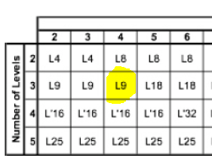

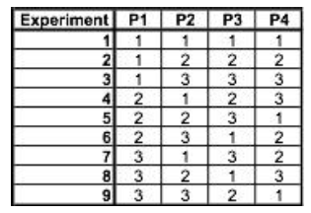

|  |  |  |  |  |  |  |  |  |  |  |  |  |  |
| --- | --- | --- | --- | --- | --- | --- | --- | --- | --- | --- | --- | --- | --- |
|  | PM | PX | ES | IM | 1 | 2 | 3 | 4 | 5 | 6 | 7 | 8 | S/N |
|  | 0.1 | 0.3 | 0 | 2 |  |  |  |  |  |  |  |  |  |
|  | 0.1 | 0.5 | 2 | 5 |  |  |  |  |  |  |  |  |  |
|  | 0.1 | 0.7 | 10 | 10 |  |  |  |  |  |  |  |  |  |
|  | 0.3 | 0.3 | 2 | 10 |  |  |  |  |  |  |  |  |  |
|  | 0.3 | 0.5 | 10 | 2 |  |  |  |  |  |  |  |  |  |
|  | 0.3 | 0.7 | 0 | 5 |  |  |  |  |  |  |  |  |  |
|  | 0.5 | 0.3 | 10 | 5 |  |  |  |  |  |  |  |  |  |
|  | 0.5 | 0.5 | 0 | 10 |  |  |  |  |  |  |  |  |  |
|  | 0.5 | 0.7 | 2 | 2 |  |  |  |  |  |  |  |  |  |

We would like to maximize, so the formula below should be used:

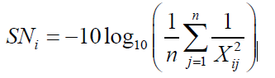

And finally, the averaged values of SNij should be put into array below:

|  |  |  |  |  |
| --- | --- | --- | --- | --- |
|  | PM | PX | ES | IM |
| Level 1 |  |  |  |  |
| Level 2 |  |  |  |  |
| Level 3 |  |  |  |  |
| min |  |  |  |  |
| max |  |  |  |  |
| Δ |  |  |  |  |

To start the series of tests You must execute the zsee.exe application, the choose ‘Optymalizacja’ in ‘File’ menu.

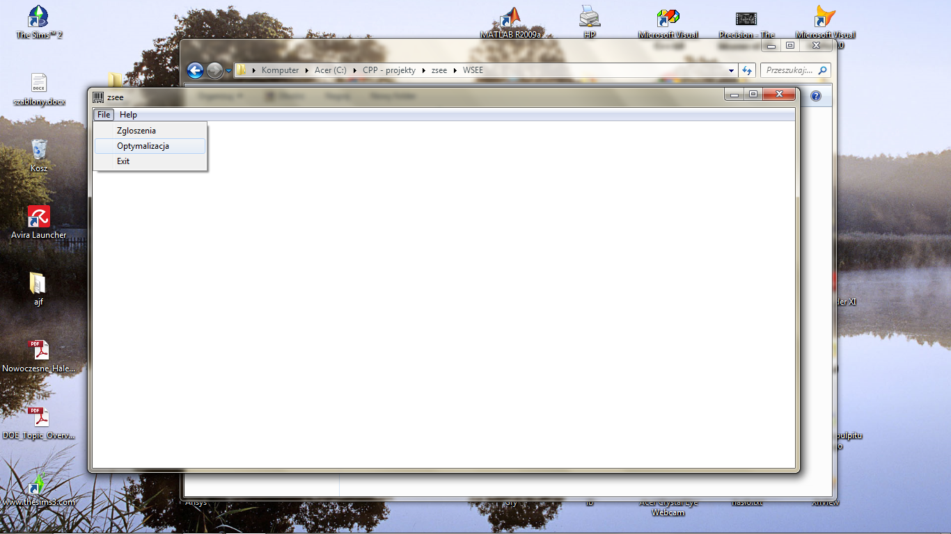

The optimization process will take a few hours. After it finishes (An “OK’ message box will appear) You will find the ‘test.txt’ file. The results are in 5th column:

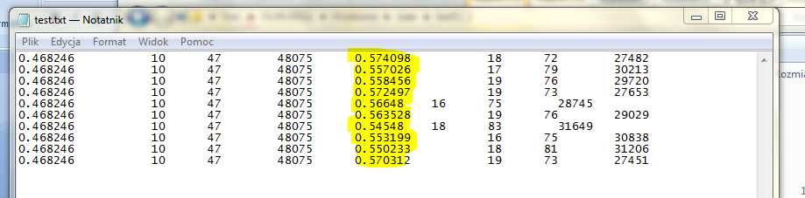

Those values are Xij to be introduced directly to Taguchi calculation.

So You must change the values in TEST.PAR file, start the optimization series, write the results for all 9 series.

After it You can do the Taguchi calculations.